Software Requirements and Analysis Document
For
Extendable Desktop Search

Prepared by

K.Vineel Kumar Reddy N.Nischala
S.Rajendhran Bharat Nikitha
Rahul Kumar

Table of Contents

1. Introduction 3
1.1 Purpose 3
1.2 Project Scope 3
1.3 References 3

2. Overall Description 4
2.1 Product Perspective 4
2.2 Product Features 4
2.3 Product Feasibility 4
2.4 User Classes and Characteristics 5
2.5 Operating Environment 5
2.6 Design and Implementation Constraints 6
2.7 Assumptions and Dependencies 6

3. System Features 7
3.1 Quering the files by name 7
3.2 Quering the files by content 7
3.3 Supports an elegent plug-in Interface 8
3.4 Indexing of remote systems data 9

4. External Interface Requirements 9
4.1 User Interfaces 9
4.2 Hardware Interfaces 10
4.3 Software Interfaces 11

5. Other Requirements 12
5.1 Performance Requirements 12
5.2 Security Requirements 13
5.3 Software Quality Attributes 13

Introduction

Purpose

Nowadays with the increase in the size of hard disc, locating a file or useful information in the system has become a tedious task, making traditional searching process a futile exercise. To address this problem we are going for desktop search. The core of any desktop search engine is the process of Indexing. Using desktop search the results (hits) are obtained almost instantaneously.

Project Scope
Our Extensible Desktop Search supports an elegant plug-in architecture. It is capable of indexing content of the documents and metadata of the audio, video files. It can process major document file types like pdf, doc, txt, html using their respective parsers. It not only indexes the file contents but also capable of indexing emails and Internet explorer contacts.

It will be capable of indexing data present on both local, remote systems connected in LAN

The objective of this application is to provide an alternative to commercially available desktop search engines that is scalable, extensible and be able to run with minimal hardware requirements.

References
- Identifying Keywords in Metadata and Full-Text Search: http://www.kbs.uni-hannover.de/Arbeiten/Publikationen/2005/ISWC.pdf
- Semantically Enhanced Searching and Ranking: http://www.kbs.uni-hannover.de/Arbeiten/Publikationen/2005/desktop_ranking.pdf
- Inverted Index Construction: http://remote.science.uva.nl/~christof/courses/ir/transparencies/clean-w-05.pdf
- Google Desktop SDK Reference: http://desktop.google.com/dev/gadgetapi.html
- Apache Lucene Text Indexing Reference: http://lucene.apache.org/java/docs/

Overall Description

Product Perspective
Many of the commercial desktop search softwares from Google, Copernic etc are not satisfactory because they target only novice users and do not address the needs of the professional users. They do not provide any useful tools to analyze the indexes. The file format of the indexes is also proprietary as a result, users of a particular product have no chance of enhancing its capabilities.

So our extendable desktop search is designed as a better alternative for the existing products.

Product Features
- Capable of indexing local and remote systems connected in LAN
- Less CPU(works with 1.6GHz onwards) and Memory( uses < 30MB) consumption
- Supports well defined plug-in framework, to enhance its capabilities by 3rd parties
- Indexing process is completely transparent to the user
- Automatically schedules itself to system idle times
- Automatically monitors the files that has got modified, created, deleted and updates the indexes accordingly
- Works on all versions of windows NT

Product Feasibility
This application is very much useful for organizations that necessitate the faster and efficient way of organizing and retrieving the information

It addresses the basic problem of information retrieval (IR) faced by almost every user with reasonable data in his/her machine.

It uses rich featured technology (.NET) for its development and uses the benefits of currently available software development tools like NUnit Testing framework, NDoc, FxCop, Visual C# Express Edition.

It can be implemented with open source libraries (tagcharplib, NUnit) that are available free of cost and can be completed with very low budget.

User Classes and Characteristics
All users find this application very useful because of the increase in the size of hard disc day by day and making the conventional file searching process really painful.

We divided our users into two classes

- Novice User : This class of users are interested in basic searching capabilities
of the product. Typically they pose queries for a file,
based on its ‘name’ or by its ‘content’ (like knowing the word
in the content of a file)

- Professional User: This class of users are interested in advanced searching
capabilities of the product and pose ad hoc queries.
Typically they try to fine tune their queries by using
various advanced operators available in our extendable
desktop search like

      - Case Sensitive content searching
      - Last Modified, Last Accessed file
      - File attributes like Hidden, Read-only etc.
      - Metadata Attributes like ‘bit rate’ information
      - Tweak the ranking of results(hits)

Though extendable desktop search targets both classes of users, the application is biased towards advanced users and provides complete control on the searching process.

Operating Environment
Hardware
- Processor: Intel 1.6GHz
- Memory: 256MB
- Hard Disc: 10MB

Software
- OS: Windows NT
- Framework: .NET 2.0

It can coexist with all other software products that are present on end user machine.

Design and Implementation
We have chosen .NET as our technology because of 3 reasons

- .NET is cross language interoperable – which facilitates 3rd parties to write plug-ins in any .NET aware languages

- .NET is a rich featured framework with well organized collection of classes. This alleviates us from writing boiler plate code and helps us to concentrate on the core implementation logic of the project.

- .NET provides better integration features to windows operating system(which is not the case with other languages like JAVA)

C# is chosen as the language of implementation because of its strong support for component oriented programming paradigms and versioning capabilities.

Development of this software is entirely done using Visual C# Express Edition 2005

To provide consistent code base for the entire project, our team follows the design conventions and programming standards specified by

- C# Language conventions: http://www.tiobe.com/standards/gemrcsharpcs.pdf
- .NET Naming Guidelines: http://msdn2.microsoft.com/en-us/library/xzf533w0(VS.71).aspx
- Design Patterns: http://msdn.microsoft.com/msdnmag/issues/01/07/patterns/

Assumptions and Dependencies
- Extendable Desktop Search requires .NET framework 2.0 installed on the end user machine.

- .NET framework 2.0 is available free at http://www.microsoft.com/downloads/details.aspx?FamilyID=0856EACB-4362-4B0D-8EDD-AAB15C5E04F5

- As desktop search runs as a background service(daemon), it requires Administrator privileges to tweak its service setting(tweaking normal program setting do not require this)

- The software is built as a standalone application, does not have any external dependencies with the existing components on the user machine.

System Features
The following are the major system features for the application. This section of the document gives an overview of the functional requirements, services provided by the application and their targeted class of users.

Querying the files by its name
3.1.1 Description
Majority of users will search for the desired files based on their name
so this system feature is given the highest priority.
This feature does not have any performance impact on the application
because the length of file name in any file system is limited to 1024
characters.

3.1.2 Functional Requirements
This feature requires the implementation of regular expressions to support queries like “files ending with txt extension”, “files starting with ‘a’ and of length 6 characters” etc.
This feature handles the invalid inputs given by the user and tries to anticipate the relevant query. For example if the user has typed “kernl32.dll” as the file name, it automatically detects the misspelled file name and suggests the user with the correct one as “Kernel32.dll”.

Querying the files by its content
3.2.1 Description
This feature provides an extra level of information retrieval by allowing
user to query for the desired file based on its contents rather than its
name.

This feature has some performance impact on the indexing process if
the content of the file to be indexed is greater than 5MB. The user can
choose between the indexing of complete document or only first few
pages of the document.

3.2.2 Functional Requirements
The contents of the files vary with each file type, for example the file format of Microsoft Word is completely different from that of Adobe’s Pdf (portable document format).
This particular feature necessitates the use of content parsers.
The content parser module is used to handle all major file types. The
input to this module is a file (parser specific) and the output is textual
content, which will be fed as an input to the indexer.

The content to be indexed can be controlled based on the size of the
file. Larger files can be limited to index only first few pages.

Support an elegant plug-in interface
3.3.1 Description
This feature targets the professional users and 3rd parties interested in
extending the features of the application. It provides an extra
dimension to the software by providing a simple plug-in interface.

3.3.2 Functional Requirements
To be able to accept an extension as a plug-in it should implement and confine to the application plug-in specification.
Every extension should be able the parse the input content and return the results back to the caller in a list containing KEY, VALUE pairs.
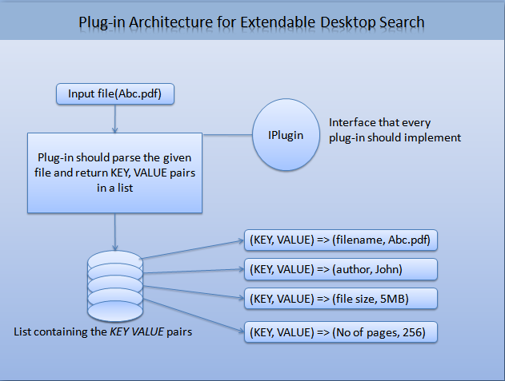

Indexing of remote system’s data
3.4.1 Description
This system feature is very much important in places like labs where
an administrator can index the contents of all the systems without
actually installing it on each client.

This also helps the administrator in searching the contents of the
remote client from his machine.

3.4.2 Functional Requirements
Indexing of remote systems require administrator privileges on that
machine.

The systems need to be connected in LAN to access each other,
data transfer between the systems should be fast.

This feature targets the advanced user class.

External Interface Requirements

User Interfaces
Extendable desktop search provides user interface for following content types

- Documents
- Pictures
- Audio
- Video
- Email
- Query Builder for professional users(to process ad hoc queries)

The user interface of extendable desktop search will be developed in reference to windows GUI standards at http://www.gpa.etsmtl.ca/cours/gpa789/pdf/OfficialGUI.pdf

This software will be developed with usability in mind. It provides familiar keyboard shortcuts, uses standard GUI controls.

The following figure shows the prototype design of the extendable desktop search. It uses familiar tabbed interface to navigate from one type of data to other and strictly confines to the GUI guidelines.

If an illegal interaction is performed with the application the user will be displayed with meaningful error messages.

The GUI is designed based on the content types that the application can handle.

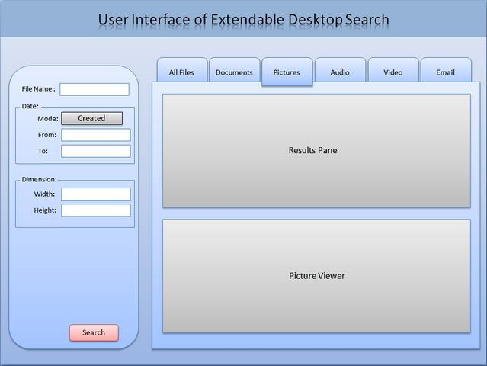

Hardware Interfaces
The main hardware component that will be used by the application is hard disc with at least 200MB of free space for indexes. SATA hard disc are more preferable because of its faster data access speed.

The created indexes are portable in nature and so indexes created on one system can be easily deployable to other identical machines, which eliminates the cost of re-indexing the content on the new machine.

The application is designed to use not more than 20% of the available CPU time to accomplish the indexing process, 20MB of available RAM - makes the application a better choice even at resource intensive places like heavy workload servers.

Software Interfaces
This section of the document identifies the structural relations between various modules. This project mainly comprises of following five modules

- Indexing Module: This is the core component responsible for indexing the contents of major document formats (.doc, .pdf), metadata attributes of audio and other binary file formats.

Indexing module will intelligently assign a ranking factor to the file being indexed, based on the number of times the file got updated/read.

The indexing module can only understand the data in textual format, as a result, extraction of textual information from documents and other binary files will be handled by Content Parsers module.

The textual information given to indexing modules will be in KEY, VALUE pair. For example if ‘content’ is the key then the document’s content is the value, if ‘author’ is the key then the file author name is the value.

The indexing module filters the unnecessary linguistic words (an, the, in etc) from being indexed, greatly reducing the size of indexes. This module uses Inverted Indexing scheme to organize the data.

- Content Parsers Module: This comprises of various parsers that can handle (parse) their respective file types.

The input to this module is a file (parser specific) and the output is textual content, which will be fed as an input to the indexer.

As an example, if input to this module is a doc file then the output will be a plain text extracted from the doc file, similarly if the input is an audio file then the output will be all metadata attributes like bit rate, composer etc

- File System Monitoring Module: The responsibility of this module is to look after the file system changes that have occurred due to creation, deletion, updation of files by the user. It then analyses the changes and triggers File System Crawler to update the indexes. It will also monitor the open files that are being used by the currently running processes in the system, as these files are more likely to be modified (a file opened in notepad has more chance of getting modified than the files not opened by any process).

- File System Crawler Module: It will scan the hard disc at regular intervals to collect the files that need to be indexed and maintains them in a queue. This module is designed to calculate the CPU’s idle time to schedule itself for the next scan. In this way the user at work will not be interrupted by the crawling activity.

- Query Builder Module: This module is the information retrieval component of the software. The input to this module is a query (which will be given by the user by selecting various options).The given query is analyzed by this module and fetch the results according to the ranking assigned from the indexes.

The following are the software components and frameworks that are being used in this product for its development

- .NET framework 2.0, for the software’s core implementation
- Taglib-sharp-1.9, is a free open source metadata extracting library from popular audio formats(mp3,ogg etc)
- Zlib 1.2, is a free open source compression library used for compressing the created indexes to reduce the hard disc space usage.

Other Requirements

Performance Requirements
The performance bottleneck of the application is caused by indexing, file system crawler modules. At most care will be taken to optimize the routines constituting these modules by carefully estimating and utilizing the available system resources.

To estimate the available system resources, we will be using various system Performance Counters like

- Processor % Idle Time, which gives the effective number of processor cycles that are free to be utilized by the applications.

- Time elapsed between the user’s interactions(keyboard, mouse) with the system( using a routine GetLastInputInfo() )

- Average disk bytes Read/Written per sec gives a measure to know whether the hard disc is idle or busy flushing its buffers.

- Average page faults counter gives an account for the usage of RAM by the indexing module.

The application can automatically scale itself to multiprocessor systems and can make effective use of recent multicore processors; this incredibly enhances the overall performance of the application.

Security Requirements
Indexing of confidential data is protected by encrypting the created indexes. As the directories containing indexes are protected by enforcing NTFS file permission all users cannot cripple them.

Tweaking application settings related to its service requires administrative privileges.

Software Quality Attributes
Adaptability: This application is designed to be adaptable to major hardware and
software configuration. It is made possible by not confining to a
specific hardware, software configuration available to it.

Correctness: The application accounts for the correctness of the results based on
the ranking factor.

Usability: This software will be developed with usability in mind. It provides familiar
keyboard shortcuts, uses standard GUI controls.

Reliability: The application will not crash even with unexpected system failures; it is
possible because the application automatically saves a copy of indexed
content to a temporary location at regular intervals of time. In this way the
application is made reliable in disaster situations.

